

LAB ASSIGNMENT 1

# SUBMITTED TO:

**Prof. Nalini N**

# School of Computer Science and Engineering

|  |  |
| --- | --- |
| **Name:** | **Divij Bahl** |
| **Registration Number:** | 19BCE0789 |

**ACTIVITY 1**

**Design a web page with image map and map the areas of buildings.**

**Image Used:**

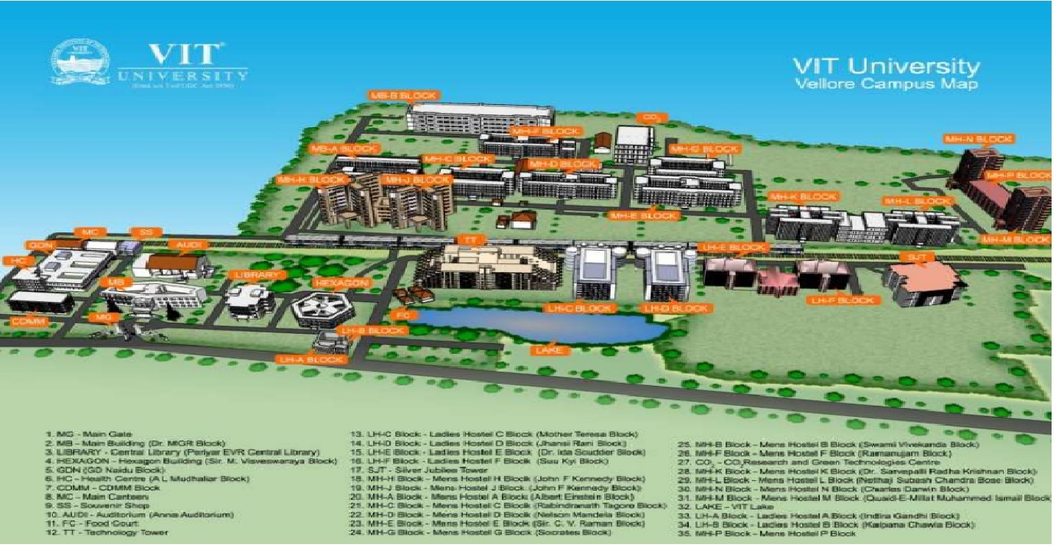

**Program Code:**

<!DOCTYPE html>

<html>

<head>

<meta charset="utf-8" />

<meta name="viewport" content="width=device-width, initial-scale=1, shrink-to-fit=no" />

<title> VIT </title>

</head>

<body>

<h1>VIT UNIVERSITY, VELLORE</h1>

<img src="vit.jpg" alt="vit-map" width="1000" height="600" usemap="#vit-map">

<map name="vit image-map">

<area target="" alt="TT" title="TT" href="tt.html" coords="760,393,563,332" shape="rect">

<area target="" alt="SJT" title="SJT" href="sjt.html" coords="1207,419,1300,355" shape="rect">

<area target="" alt="HEXAGON" title="HEXAGON" href="hexagon.html" coords="466,397,481,423,418,433,392,416,420,398" shape="poly">

<area target="" alt="LIBRARY" title="LIBRARY" href="library.html" coords="309,417,366,387" shape="rect">

<area target="" alt="LAKE" title="LAKE" href="lake.html" coords="559,420,885,430,914,443,857,473,560,445" shape="poly">

<area target="" alt="MH-N BLOCK" title="MH-N BLOCK" href="mhn.html" coords="1296,203,1363,241" shape="rect">

<area target="" alt="MH-L BLOCK" title="MH-L BLOCK" href="mhl.html" coords="1211,286,1295,314" shape="rect">

<area target="" alt="MH-K BLOCK" title="MH-K BLOCK" href="mhk.html" coords="1044,282,1139,329" shape="rect">

<area target="" alt="MB" title="MB" href="mb.html" coords="141,422,273,383" shape="rect">

<area target="" alt="AUDI" title="AUDI" href="audi.html" coords="184,342,273,371" shape="rect">

<area target="" alt="MH-J BLOCK" title="MH-J BLOCK" href="mhj.html" coords="612,312,538,237" shape="rect">

<area target="" alt="MH-C BLOCK" title="MH-C BLOCK" href="mhc.html" coords="620,222,694,268" shape="rect">

<area target="" alt="MH-D BLOCK" title="MH-D BLOCK" href="mhd.html" coords="709,232,833,270" shape="rect">

<area target="" alt="LH-C BLOCK" title="LH-C BLOCK" href="lhc.html" coords="780,335,836,405" shape="rect">

<area target="" alt="LH-D BLOCK" title="LH-D BLOCK" href="lhd.html" coords="871,339,939,408" shape="rect">

<area target="" alt="LH-E BLOCK" title="LH-E BLOCK" href="lhe.html" coords="958,353,1021,388" shape="rect">

<area target="" alt="LH-F BLOCK" title="LH-F BLOCK" href="lhf.html" coords="1081,349,1148,391" shape="rect">

<area target="" alt="HCI" title="HCI" href="hci.html" coords="13,382,65,364" shape="rect">

</map>

</body>

</html>

**SCREENSHOTS:**

The image map, where we can click on different icons to visit their page.

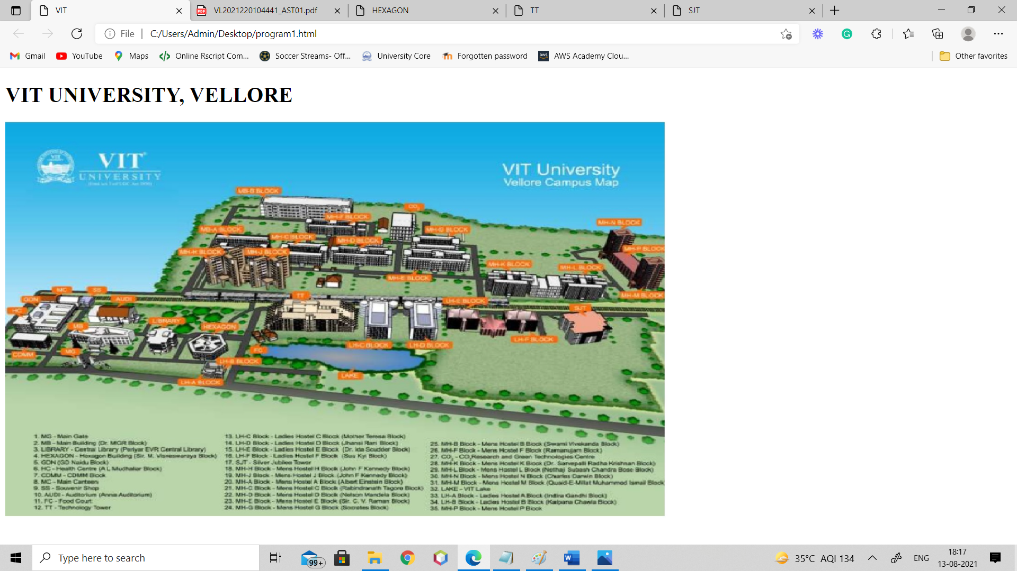

When we click on Hexagon, hexagon.html opens.

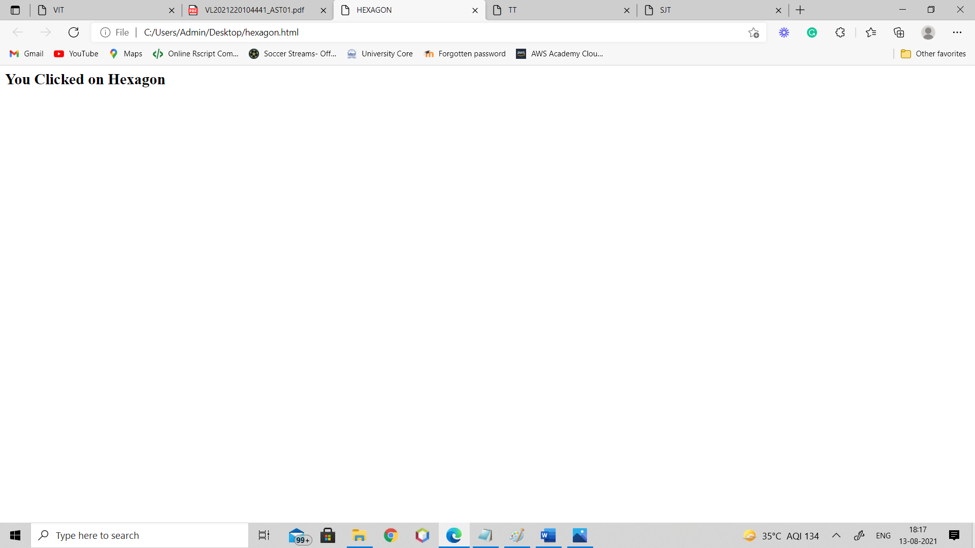

When we click on TT, tt.html opens.

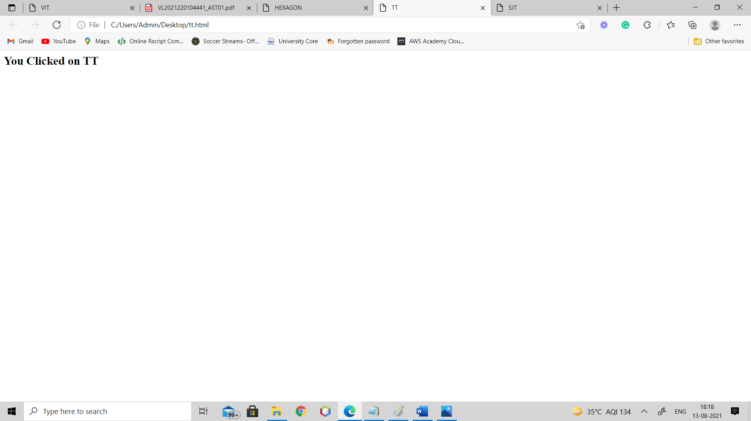

When we click on SJT, sjt.html opens.

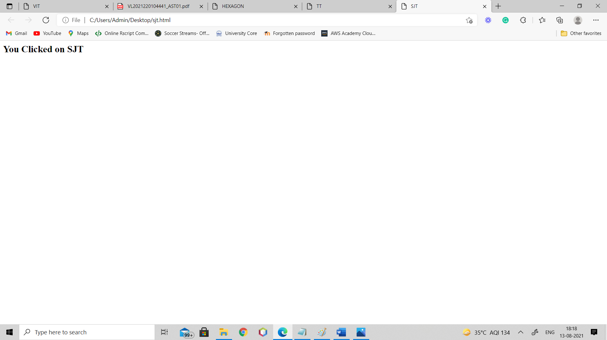

**ACTIVITY 2.**

**Design a web page for School using HTML.**

**Tags: Frame, table, link and other tags.**

**a. Home – about School and faculty details (departmentwise)**

**b. Standard wise time table with class teacher details (minimum 3-time tables)**

**c. Student Activities**

**i. Upcoming events**

**ii. About clubs**

**iii. Student achievements (embed paper cuttings)**

**d. COE**

**i. Exam time table (minimum 2-time tables)**

**ii. Result – use HTML5 form inputs(types/tags)**

**home.html:**

<html>

<head>

<title>Vellore Institute of Technology</title>

<link rel="stylesheet" href="one.css">

<link rel="icon" href="logo.jpeg" type="image/icon type">

<style>

body{

background-color: gray;

}

.topnav {

background-color: #333;

overflow: hidden;

}

.topnav a {

float: left;

color: #f2f2f2;

text-align: center;

padding: 14px 16px;

text-decoration: none;

font-size: 17px;

}

.topnav a:hover {

background-color: #ddd;

color: black;

}

.topnav a.active {

background-color: #04AA6D;

color: white;

}

#left{

padding-top: 6px;

margin-top: 16px;

margin-left: 10px;

}

.column {

float: right;

width: 25%;

color: white;

}

.row{

background-color: #333;

overflow: hidden;

height:30px;

}

.row:after {

content: "";

display: table;

clear: both;

}

footer {

text-align: center;

padding: 3px;

background-color: #333;

color: white;

}

</style

</head>

<head>

<title>Vellore Institute of Technology</title>

<link rel="stylesheet" href="one.css">

<link rel="icon" href="logo.jpeg" type="image/icon type">

</head>

<body style="background-color:powderblue;">

<!-- <frameset cols="30%,70%">

<frame src=left.html name=l>

<frame src=right.html name=f>

</frameset> -->

<div class="topnav">

<a class="active" href="http://#home">Home</a>

<a href="timetable1.html">Time Table</a>

<a href="Student1.html">Student life</a>

<a href="coe1.html">COE</a>

</div>

<table>

<tr>

<td style="padding-top:10px; padding-left:10px; padding-right:10px"> <img src="VIT_IMAGE.jpeg" alt="VIT IMAGE"

height="600px" width="700px"></td>

<td>

<h1 style="text-align:center;">About VIT</h1>

<br>

<p style="padding-left: 7px; font-size: 18px;">VIT was established with the aim of providing quality higher education on par with international standards.

It persistently seeks and adopts innovative methods to improve the quality of higher education on a consistent basis.The campus has a cosmopolitan atmosphere with students from all corners of the globe. Experienced and learned teachers are strongly encouraged to nurture the students. The global standards set at VIT in the field of teaching and research spur us on in our relentless pursuit of excellence.

In fact, it has become a way of life for us. The highly motivated youngsters on the campus are a constant source of pride. Our Memoranda of Understanding with various international universities are our major strength. They provide for an exchange of students and faculty and encourage joint research projects for the mutual benefit of these universities. Many of our students, who pursue their research projects in foreign universities, bring high quality to their work and esteem to India and have done us proud. With steady steps, we continue our march forward. We look forward to meeting you here at VIT. </p>

</td>

</tr>

</table>

<br>

<br>

<h1 style="text-align:center">

Faculty Details</h1>

<br>

<br>

<div class="row">

<div class="column"><a href="scope.html" style="color: aliceblue;">Scope</a></div>

<div class="column"><a href="site.html" style="color: aliceblue;">SITE</a></div>

<div class="column"><a href="sense.html" style="color: aliceblue;">SENSE</a></div>

<div class="column"><a href="smec.html" style="color: aliceblue;">SMEC</a></div>

</div>

<br>

<br>

<footer>

<p>Author: Divij Bahl<br>

For more information visit:

<a href="vit.ac.in">vit.ac.in</a>

</p>

</footer>

</body>

</html>

**timetable1.html:**

<!DOCTYPE html>

<html>

<head>

<title>Vellore Institute of Technology</title>

<link rel="stylesheet" href="one.css">

<link rel="icon" href="logo.jpeg" type="image/icon type">

<style>

body{

background-color: gray;

}

.topnav {

background-color: #333;

overflow: hidden;

}

.topnav a {

float: left;

color: #f2f2f2;

text-align: center;

padding: 14px 16px;

text-decoration: none;

font-size: 17px;

}

.topnav a:hover {

background-color: #ddd;

color: black;

}

.topnav a.active {

background-color: #04AA6D;

color: white;

}

#left{

padding-top: 6px;

margin-top: 16px;

margin-left: 10px;

}

.column {

float: right;

width: 25%;

color: white;

}

.row{

background-color: #333;

overflow: hidden;

height:30px;

}

.row:after {

content: "";

display: table;

clear: both;

}

footer {

text-align: center;

padding: 3px;

background-color: #333;

color: white;

}

</style

</head>

<body style="background-color:powderblue;">

<div class="topnav">

<a href="home.html">Home</a>

<a class="active" href="timetable1.html">Time Table</a>

<a href="Student1.html">Student life</a>

<a href="coe1.html">COE</a>

</div>

<br>

<br>

<h1>TIME TABLE</h1>

<table border="5" cellspacing="0" align="center">

<!--<caption>Timetable</caption>-->

<tr>

<td align="center" height="50" width="100"><br>

<b>Theory<br>Lab</b></br>

</td>

<td align="center" height="50" width="100">

<b><br>8:00 - 8:50<br>

8:00 - 8:50</b>

</td>

<td align="center" height="50" width="100">

<b><br>9:00 - 9:50<br>

8:51 - 9:40</b>

</td>

<td align="center" height="50" width="100">

<b><br>10:00 - 10:50<br>

9:51 - 10:40</b>

</td>

<td align="center" height="50" width="100">

<b><br>11:00 - 11:50<br>

10:41 - 11:30</b>

</td>

<td align="center" height="50" width="100">

<b><br>12:00 - 12:50<br>

11:41 - 12:30</b>

</td>

<td align="center" height="50" width="100">

<b><br> <br>

12:31 - 13:20</b>

</td>

<td align="center" height="50" width="100">

<b><br>14:00 - 14:50<br>

14:00 - 14:50</b>

</td>

<td align="center" height="50" width="100">

<b><br>15:00 - 15:50<br>

14:51 - 15:40</b>

</td>

<td align="center" height="50" width="100">

<b><br>16:00 - 16:50<br>

15:51 - 16:40</b>

</td>

<td align="center" height="50" width="100">

<b><br>17:00 - 17:50<br>

16:41 - 17:30</b>

</td>

<td align="center" height="50" width="100">

<b><br>18:00 - 18:50<br>

17:40 - 18:30</b>

</td>

</tr>

<tr>

<td align="center" height="50">

<b>Monday</b>

</td>

<td align="center" height="50">A1\L1</td>

<td align="center" height="50">F1\L2</td>

<td align="center" colspan="2" height="50">CSE1002 (L3+L4)</td>

<td align="center" colspan="2" height="50">CSE1003 (L5+L6)</td>

<td align="center" height="50">CSE2001 (A2 Slot)</td>

<td align="center" height="50">STS1201 (F2 Slot)</td>

<td align="center" height="50">D2\L33</td>

<td align="center" height="50">CSE2002 (TB2 Slot)</td>

<td align="center" height="50">MAT2001 (TG2 slot)</td>

</tr>

<tr>

<td align="center" height="50">

<b>Tuesday</b>

</td>

<td align="center" height="50">B1\L7</td>

<td align="center" height="50">G1\L8</td>

<td align="center" height="50">E1\L9</td>

<td align="center" height="50">TC1\L10</td>

<td align="center" colspan="2" height="50">CSE2011 (L11+L12)</td>

<td align="center" height="50">CSE2002 (B2 Slot)</td>

<td align="center" height="50">MAT2001 (G2 Slot)</td>

<td align="center" height="50">CHY1701 (E2 Slot)</td>

<td align="center" height="50">MAT1014 (TC2 Slot)</td>

<td align="center" height="50">TAA2\L41</td>

</tr>

<tr>

<td align="center" height="50">

<b>Wednesday</b>

</td>

<td align="center" colspan="2" height="50">CHY1701 (L13+L14 Slot)</td>

<td align="center" height="50">F1\L15</td>

<td align="center" height="50">V1\L16</td>

<td align="center" height="50">V2\L17

</td>

<td align="center" height="50">-\L18</td>

<td align="center" height="50">MAT1014 (C2 Slot)</td>

<td align="center" height="50">CSE2003 (A2 Slot)</td>

<td align="center" height="50">STS1201 (F2 Slot)</td>

<td align="center" height="50">TD2\L46</td>

<td align="center" height="50">TBB2\L47</td>

</tr>

<tr>

<td align="center" height="50">

<b>Thursday</b>

</td>

<td align="center" height="50">D1\L19</td>

<td align="center" height="50">B1\L20</td>

<td align="center" colspan="2" height="50">CSE1002 (L21+L22)</td>

<td align="center" height="50">TCC1\L23

</td>

<td align="center" height="50">-/L24</td>

<td align="center" height="50">D2\L49</td>

<td align="center" height="50">CSE2002 (B2 Slot)</td>

<td align="center" height="50">MAT2001 (G2 Slot)</td>

<td align="center" height="50">CHY1701 (TE2 Slot)</td>

<td align="center" height="50">MAT1014 (TCC2 Slot)</td>

</tr>

<tr>

<td align="center" height="50">

<b>Friday</b>

</td>

<td align="center" colspan="2" height="50">CSE1002 (L25+L26)</td>

<td align="center" colspan="2" height="50">MAT2001 (L27+L28)</td>

<td align="center" height="50">TD1\L29</td>

<td align="center" height="50">-\L30</td>

<td align="center" height="50">CHY1701 (E2 Slot)</td>

<td align="center" height="50">MAT1014 (C2 Slot)</td>

<td align="center" height="50">CSE2011 (TA2 Slot)</td>

<td align="center" height="50">STS1202 (TF2 Slot)</td>

<td align="center" height="50">TDD2\L59</td>

</tr>

</table>

<br>

<br><br>

<h1>TIME TABLE 2</h1>

<table border="5" cellspacing="0" align="center">

<!--<caption>Timetable</caption>-->

<tr>

<td align="center" height="50" width="100"><br>

<b>Theory<br>Lab</b></br>

</td>

<td align="center" height="50" width="100">

<b><br>8:00 - 8:50<br>

8:00 - 8:50</b>

</td>

<td align="center" height="50" width="100">

<b><br>9:00 - 9:50<br>

8:51 - 9:40</b>

</td>

<td align="center" height="50" width="100">

<b><br>10:00 - 10:50<br>

9:51 - 10:40</b>

</td>

<td align="center" height="50" width="100">

<b><br>11:00 - 11:50<br>

10:41 - 11:30</b>

</td>

<td align="center" height="50" width="100">

<b><br>12:00 - 12:50<br>

11:41 - 12:30</b>

</td>

<td align="center" height="50" width="100">

<b><br> <br>

12:31 - 13:20</b>

</td>

<td align="center" height="50" width="100">

<b><br>14:00 - 14:50<br>

14:00 - 14:50</b>

</td>

<td align="center" height="50" width="100">

<b><br>15:00 - 15:50<br>

14:51 - 15:40</b>

</td>

<td align="center" height="50" width="100">

<b><br>16:00 - 16:50<br>

15:51 - 16:40</b>

</td>

<td align="center" height="50" width="100">

<b><br>17:00 - 17:50<br>

16:41 - 17:30</b>

</td>

<td align="center" height="50" width="100">

<b><br>18:00 - 18:50<br>

17:40 - 18:30</b>

</td>

</tr>

<tr>

<td align="center" height="50">

<b>Monday</b>

</td>

<td align="center" height="50">CSE1007 (A1 slot)</td>

<td align="center" height="50">F1\L2</td>

<td align="center" height="50">D1\L3</td>

<td align="center" height="50">CSE3054 (TB1 Slot)</td>

<td align="center" height="50">CSE3049 (TG1 Slot)</td>

<td align="center" height="50">-\L6</td>

<td align="center" height="50">CSE2001 (A2 slot)</td>

<td align="center" height="50">CSE2013 (F2 slot)</td>

<td align="center" height="50">D2\L33</td>

<td align="center" height="50">CSE2031 (TB2 slot)</td>

<td align="center" height="50">TG2\L35</td>

</tr>

<tr>

<td align="center" height="50">

<b>Tuesday</b>

</td>

<td align="center" height="50">CSE3054 (B1 Slot)</td>

<td align="center" height="50">CSE3049 (G1 Slot)</td>

<td align="center" height="50">STS2201 (E1 Slot)</td>

<td align="center" height="50">CSE2005 (TC1 Slot)</td>

<td align="center" height="50">TAA1\L11</td>

<td align="center" height="50">-\L12</td>

<td align="center" height="50">CSE2031 (B2 Slot)</td>

<td align="center" height="50">G2\L38</td>

<td align="center" colspan="2" height="50">CSE1007 (L39+L40)</td>

<td align="center" height="50">TAA2\L41</td>

</tr>

<tr>

<td align="center" height="50">

<b>Wednesday</b>

</td>

<td align="center" height="50">CSE2005 (C1 Slot)</td>

<td align="center" height="50">CSE1007 (A1 Slot)</td>

<td align="center" height="50">F1\L15</td>

<td align="center" height="50">V1\L16</td>

<td align="center" height="50">V2\L17

</td>

<td align="center" height="50">-\L18</td>

<td align="center" height="50">C2\L43</td>

<td align="center" height="50">CSE2001 (A2 Slot)</td>

<td align="center" height="50">CSE2013 (F2 Slot)</td>

<td align="center" height="50">TD2\L46</td>

<td align="center" height="50">TBB2\L47</td>

</tr>

<tr>

<td align="center" height="50">

<b>Thursday</b>

</td>

<td align="center" height="50">D1\L19</td>

<td align="center" height="50">CSE3054 (B1 Slot)</td>

<td align="center" height="50">CSE3049 (G1 Slot)</td>

<td align="center" height="50">STS2201 (TE1 Slot)

</td>

<td align="center" height="50">TCC1\L23</td>

<td align="center" height="50">-\L24</td>

<td align="center" height="50">D2\L49</td>

<td align="center" height="50">CSE2031 (B2 Slot)</td>

<td colspan="2" align="center" height="50">CSE2005 (L51+L52)</td>

<td align="center" height="50">TCC2\L53</td>

</tr>

<tr>

<td align="center" height="50">

<b>Friday</b>

</td>

<td align="center" height="50">STS2201 (E1 Slot)</td>

<td align="center" height="50">CSE2005 (C1 Slot)</td>

<td align="center" height="50">CSE1007 (TA1 Slot)</td>

<td align="center" height="50">TF1\L28</td>

<td align="center" height="50">TD1\L29</td>

<td align="center" height="50">-\L30</td>

<td align="center" colspan="2" height="50">CSE2031 (L55+L56)</td>

<td align="center" height="50">CSE2001 (TA2 Slot)</td>

<td align="center" height="50">CSE2013 (TF2 Slot)</td>

<td align="center" height="50">TDD2\L59</td>

</tr>

</table>

<br>

<br>

<br>

<center>

<h1>Time Table 3</h1><br><br>

<table cellpadding='10px' border="2px">

<tr>

<th>S.no.</th>

<th>Class Group</th>

<th>Course</th>

<th>Category</th>

<th>Slot</th>

</tr>

<tr>

<td>1</td>

<td>General (Semester)</td>

<td>CSE2002 - ( Theory Only )</td>

<td>Theory of Computation and Compiler Design</td>

<td>A1+TA1+TAA1</td>

</tr>

<tr>

<td>2</td>

<td>General (Semester)</td>

<td>CSE4001 - Parallel and Distributed Computing

( Embedded Theory and lab )</td>

<td>Programme Core</td>

<td>B1+TB1</td>

</tr>

<tr>

<td>3</td>

<td>General (Semester)</td>

<td>CSE3002 - Internet and Web Programming

( Embedded Theory and lab </td>

<td>Programme Core</td>

<td>G1+TG1</td>

</tr>

<tr>

<td>4</td>

<td>General (Semester)</td>

<td>CSE2012 - Design and Analysis of Algorithms

( Embedded Theory )</td>

<td>Programme Core</td>

<td>F1+TF1</td>

</tr>

</table>

<br><br><br>

<table cellpadding='10px' style="border-collapse: collapse;" border="1px" border-color="black">

<tr bgcolor="grey" style="color:white">

<th rowspan="2">Theory</th>

<th>Start</th>

<td>8:00</td>

<td>9:00</td>

<td>10:00</td>

<td>11:00</td>

<td rowspan="100" style="background-color:#ddd;color:black">Lunch</td>

<td>2:00</td>

<td>3:00</td>

<td>4:00</td>

<td>5:00</td>

</tr>

<tr bgcolor="grey" style="color:white">

<th>END</th>

<td>8:50</td>

<td>9:50</td>

<td>10:50</td>

<td>11:50</td>

<td>2:50</td>

<td>3:50</td>

<td>4:50</td>

<td>5:50</td>

</tr>

<tr bgcolor="grey" style="color:white">

<th rowspan="2">LAB</th>

<th>Start</th>

<td>8:00</td>

<td>9:51</td>

<td>10:51</td>

<td>11:41</td>

<td>2:00</td>

<td>3:51</td>

<td>4:51</td>

<td>5:41</td>

</tr>

<tr bgcolor="grey" style="color:white">

<th>END</th>

<td>8:50</td>

<td>9:40</td>

<td>10:40</td>

<td>11:30</td>

<td>2:50</td>

<td>3:40</td>

<td>4:40</td>

<td>5:30</td>

</tr>

<tr>

<th rowspan="2">MON</th>

<th>THEORY</th>

<td>CSE2012</td>

<td>CSE2004</td>

<td>D1</td>

<td>CSE2005</td>

<td>CSE2012</td>

<td>CSE2004</td>

<td>D1</td>

<td>CSE2005</td>

</tr>

<tr>

<th>LAB</th>

<td>-</td>

<td>-</td>

<td>L3</td>

<td>-</td>

<td>-</td>

<td>-</td>

<td>L30</td>

<td>-</td>

</tr>

<tr>

<th rowspan="2">TUE</th>

<th>THEORY</th>

<td>A1</td>

<td>F1</td>

<td>CSE2005</td>

<td>B1</td< /tr>

<td>A1</td>

<td>F1</td>

<td>CSE2005</td>

<td>B1</td< /tr>

<tr>

<th>LAB</th>

<td>L1</td>

<td>L2</td>

<td>-</td>

<td>L4</td>

<td>L32</td>

<td>L33</td>

<td>-</td>

<td>L35</td>

</tr>

<tr>

<th rowspan="2">WED</th>

<th>THEORY</th>

<td>A1</td>

<td>CSE2012</td>

<td>G1</td>

<td>B1</td< /tr>

<td>A1</td>

<td>CSE2012</td>

<td>G1</td>

<td>B1</td< /tr>

<tr>

<th>LAB</th>

<td>L1</td>

<td>-</td>

<td>L3</td>

<td>L4</td>

<td>L36</td>

<td>-</td>

<td>L38</td>

<td>L39</td>

</tr>

<tr>

<th rowspan="2">THU</th>

<th>THEORY</th>

<td>CSE2001</td>

<td>F1</td>

<td>G1</td>

<td>B1</td>

<td>CSE2001</td>

<td>F1</td>

<td>G1</td>

<td>B1</td>

</tr>

<tr>

<th>LAB</th>

<td>-</td>

<td>L2</td>

<td>L3</td>

<td>L4</td>

<td>-</td>

<td>L41</td>

<td>L42</td>

<td>L43</td>

</tr>

<tr>

<th rowspan="2">FRI</th>

<th>THEORY</th>

<td>CSE2004</td>

<td>CSE2001</td>

<td>G1</td>

<td>CSE2005</td>

<td>CSE2004</td>

<td>CSE2001</td>

<td>G1</td>

<td>CSE2005</td>

</tr>

<tr>

<th>LAB</th>

<td>-</td>

<td>-</td>

<td>L3</td>

<td>-</td>

<td>-</td>

<td>-`</td>

<td>L46</td>

<td>-</td>

</tr>

</table>

</center>

</body>

</html>

**student1.html:**

<html>

<head>

<title>Vellore Institute of Technology</title>

<link rel="stylesheet" href="one.css">

<link rel="icon" href="logo.jpeg" type="image/icon type">

<style>

body{

background-color: gray;

}

.topnav {

background-color: #333;

overflow: hidden;

}

.topnav a {

float: left;

color: #f2f2f2;

text-align: center;

padding: 14px 16px;

text-decoration: none;

font-size: 17px;

}

.topnav a:hover {

background-color: #ddd;

color: black;

}

.topnav a.active {

background-color: #04AA6D;

color: white;

}

#left{

padding-top: 6px;

margin-top: 16px;

margin-left: 10px;

}

.column {

float: right;

width: 25%;

color: white;

}

.row{

background-color: #333;

overflow: hidden;

height:30px;

}

.row:after {

content: "";

display: table;

clear: both;

}

footer {

text-align: center;

padding: 3px;

background-color: #333;

color: white;

}

</style

</head>

<body style="background-color:powderblue;">

<!-- <frameset cols="30%,70%">

<frame src=left.html name=l>

<frame src=right.html name=f>

</frameset> -->

<div class="topnav">

<a href="home.html">Home</a>

<a href="timetable1.html">Time Table</a>

<a class="active" href="Student1.html">Student life</a>

<a href="coe1.html">COE</a>

</div>

<section>

<div>

<h1>Student Activities</h1>

<ul class="activities">

<li>

<h2>Upcoming events</h2>

<div class="info">

<ul>

<li>15-08-2021 Table Tennis tournament</li>

<li>16-08-2021 Football tournament</li>

<li>17-08-2021 Trekking</li>

<li>18-08-2021 Go Pro with Robots</li>

<li>19-08-2021 Web Development</li>

<li>20-08-2021 Quiz on Ethics</li>

<li>21-08-2021 Mozilla Firefoc Club meet</li>

</ul>

</div>

</li>

<li>

<h2>About Clubs & Chapters</h2>

<h2>Clubs</h2>

<div class="info">

<ul>

<li>Arts </li>

<li>Cultural</li>

<li>Technical</li>

<li>Social Outreach</li>

<li>Health & Wellness</li>

<li>Literature</li>

<li>Sports</li>

<li>Awareness</li>

</ul>

</div>

<h2>Chapters</h2>

<div class="info">

<ul>

<li>Technical Chapters</li>

<li>Indian Societies</li>

<li>International Societies</li>

<li>IEEE Chapters</li>

<li>Campaigns and Drives</li>

</ul>

</div>

</li>

<li>

<h2>Student Achievements</h2>

<div class="info">

<ul>

<li>

<div><img src="second.jpg"></div><br>

<div></div>Honorable Mention to Divij Bahl by VITMUN. Represented Croatia in VITMUN.

</div>

</li><br>

<li>

<div><img src="first.jpg"></div><br>

<div>Mr. Aryan developed a model that can travel in space using thrust.</div>

</li><br>

<li>

<div><img src="cutout3.jpeg"></div><br>

<div>Mr. Alok Nath has developed a research paper on medicine that can help regenerate the lip cells faster</div>

</li><br>

<li>

<div><img src="cutout4.jpeg"></div><br>

<div>Mr. Ayaan Zayn has represented India in Olympics 2020.</div>

</li>

</ul>

</div>

</li>

</ul>

</div>

</section>

</body>

</html>

**coe1.html:**

<html>

<head>

<title>Vellore Institute of Technology</title>

<link rel="stylesheet" href="one.css">

<link rel="icon" href="logo.jpeg" type="image/icon type">

<style>

body{

background-color: gray;

}

.topnav {

background-color: #333;

overflow: hidden;

}

.topnav a {

float: left;

color: #f2f2f2;

text-align: center;

padding: 14px 16px;

text-decoration: none;

font-size: 17px;

}

.topnav a:hover {

background-color: #ddd;

color: black;

}

.topnav a.active {

background-color: #04AA6D;

color: white;

}

#left{

padding-top: 6px;

margin-top: 16px;

margin-left: 10px;

}

.column {

float: right;

width: 25%;

color: white;

}

.row{

background-color: #333;

overflow: hidden;

height:30px;

}

.row:after {

content: "";

display: table;

clear: both;

}

footer {

text-align: center;

padding: 3px;

background-color: #333;

color: white;

}

</style

</head>

<body style="background-color:powderblue;">

<!-- <frameset cols="30%,70%">

<frame src=left.html name=l>

<frame src=right.html name=f>

</frameset> -->

<div class="topnav">

<a href="home.html">Home</a>

<a href="timetable1.html">Time Table</a>

<a href="Student1.html">Student life</a>

<a class="active" href="coe1.html">COE</a>

</div>

<br>

<br>

<center>

<h1>Time Table 1</h1><br><br>

<table cellpadding='10px' border="2px">

<tr>

<th>S.no.</th>

<th>Class Group</th>

<th>Course</th>

<th>Category</th>

<th>Slot</th>

<th>EXAM DATE</th>

<th>REPORTING TIME</th>

<th>START TIME</th>

<th>EXAM DURATION</th>

</tr>

<tr>

<td>1</td>

<td>General (Semester)</td>

<td>CSE2001 - Computer Architecture and Organization

( Theory Only )</td>

<td>Programme Core</td>

<td>A</td>

<td>16-08-2021</td>

<td>9:30 AM</td>

<td>10:00 AM</td>

<td>1.5 hrs.</td>

</tr>

<tr>

<td>2</td>

<td>General (Semester)</td>

<td>CSE2004 - Database Management Systems

( Embedded Theory )</td>

<td>Programme Core</td>

<td>B</td>

<td>17-08-2021</td>

<td>9:30 AM</td>

<td>10:00 AM</td>

<td>1.5 hrs.</td>

</tr>

<tr>

<td>3</td>

<td>General (Semester)</td>

<td>CSE2005 - Operating Systems

( Embedded Theory </td>

<td>Programme Core</td>

<td>C</td>

<td>18-08-2021</td>

<td>9:30 AM</td>

<td>10:00 AM</td>

<td>1.5 hrs.</td>

</tr>

<tr>

<td>4</td>

<td>General (Semester)</td>

<td>CSE2012 - Design and Analysis of Algorithms

( Embedded Theory )</td>

<td>Programme Core</td>

<td>D</td>

<td>19-08-2021</td>

<td>9:30 AM</td>

<td>10:00 AM</td>

<td>1.5 hrs.</td>

</tr>

</table>

<h1>Time Table 2</h1><br><br>

<table cellpadding='10px' border="2px">

<tr>

<th>S.no.</th>

<th>Class Group</th>

<th>Course</th>

<th>Category</th>

<th>Slot</th>

<th>EXAM DATE</th>

<th>REPORTING TIME</th>

<th>START TIME</th>

<th>EXAM DURATION</th>

</tr>

<tr>

<td>1</td>

<td>General (Semester)</td>

<td>CSE2001 - Computer Architecture and Organization

( Theory Only )</td>

<td>Programme Core</td>

<td>A</td>

<td>16-08-2021</td>

<td>9:30 AM</td>

<td>10:00 AM</td>

<td>1.5 hrs.</td>

</tr>

<tr>

<td>2</td>

<td>General (Semester)</td>

<td>CSE2004 - Database Management Systems

( Embedded Theory )</td>

<td>Programme Core</td>

<td>B</td>

<td>17-08-2021</td>

<td>9:30 AM</td>

<td>10:00 AM</td>

<td>1.5 hrs.</td>

</tr>

<tr>

<td>3</td>

<td>General (Semester)</td>

<td>CSE2005 - Operating Systems

( Embedded Theory </td>

<td>Programme Core</td>

<td>C</td>

<td>18-08-2021</td>

<td>9:30 AM</td>

<td>10:00 AM</td>

<td>1.5 hrs.</td>

</tr>

<tr>

<td>4</td>

<td>General (Semester)</td>

<td>CSE2012 - Design and Analysis of Algorithms

( Embedded Theory )</td>

<td>Programme Core</td>

<td>D</td>

<td>19-08-2021</td>

<td>9:30 AM</td>

<td>10:00 AM</td>

<td>1.3 hrs.</td>

</tr>

</table><br><br><br>

<h1 style="text-align:center">Results check</h1><br><br>

<h2>Please enter the mentioned details to know the result of previous semester</h2>

<form action="#">

<P>NAME: <input type="text" name="name" value=""></P><br>

<p>Reg no.: <input type="text" name="regn " value=""></p><br>

<p>Password: <input type="text" name="name " value=""></p><br>

<button>Check result</button>

</form>

</body>

</html>

**SCREENSHOTS:**

**Home Page**

**About VIT**

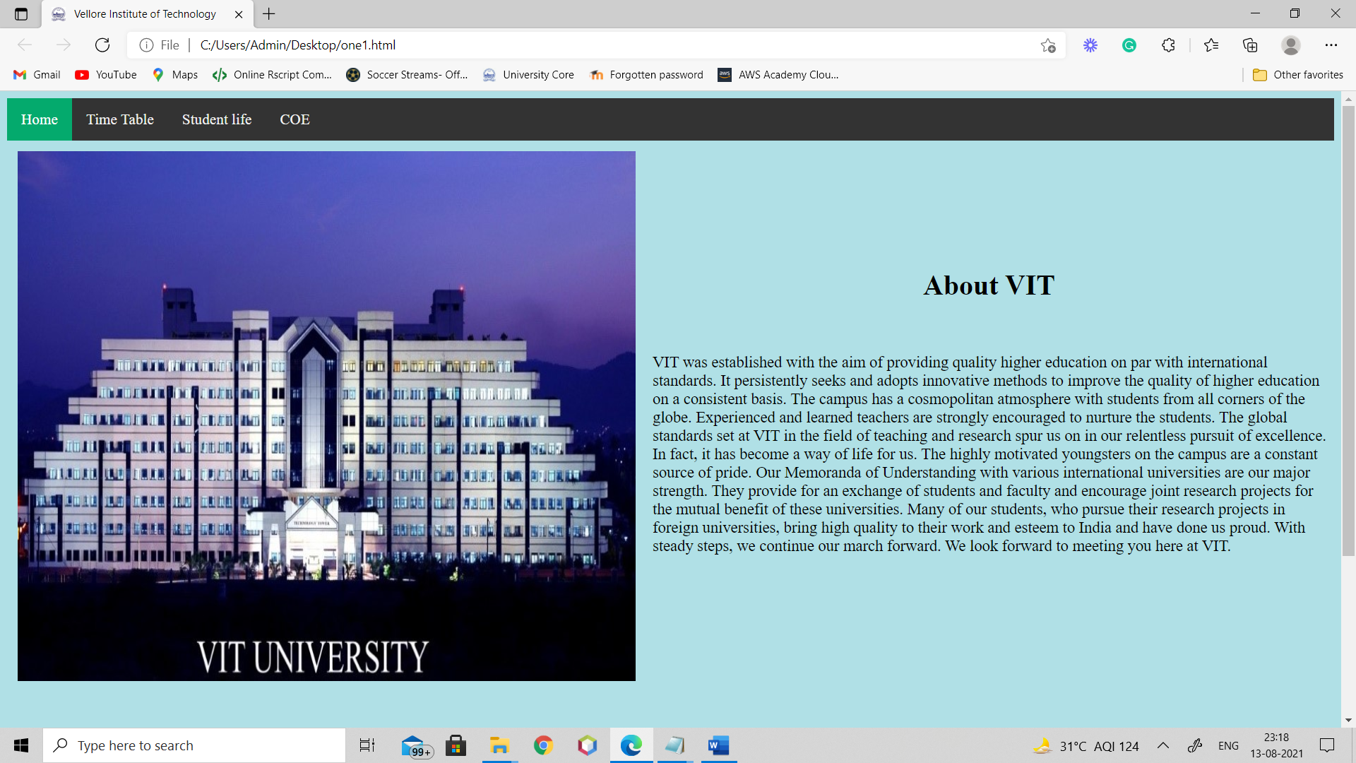

**Faculty Details from different schools**

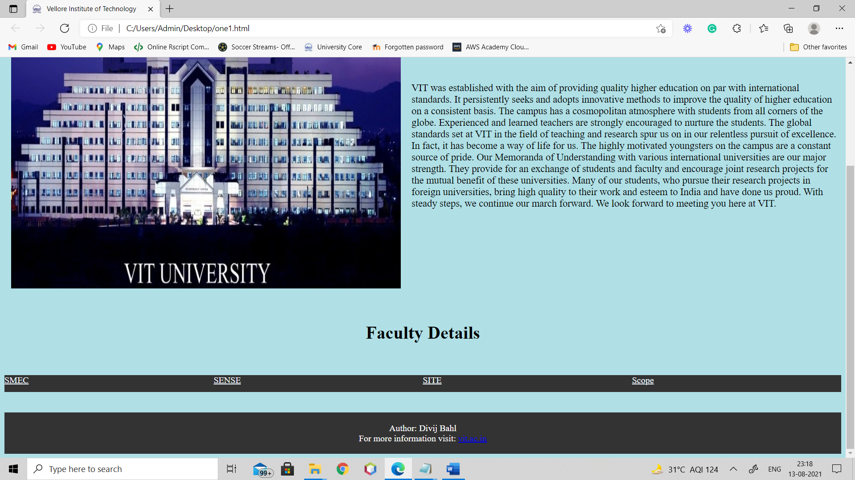

**Time table page:**

**Time table 1**

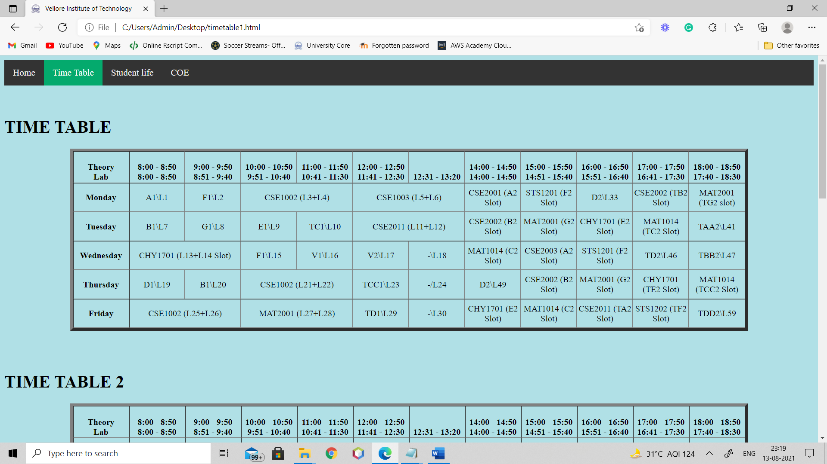

**Time Table 2**

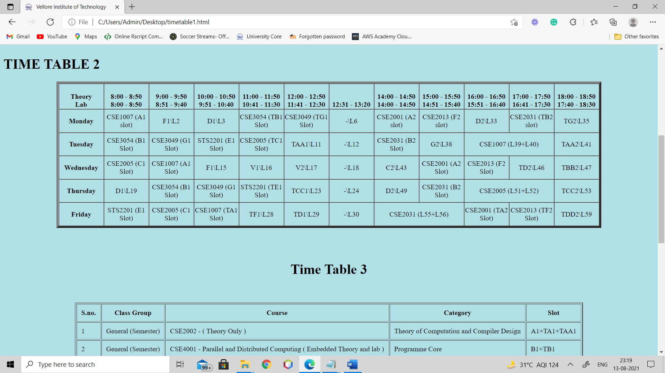

**Time table 3**

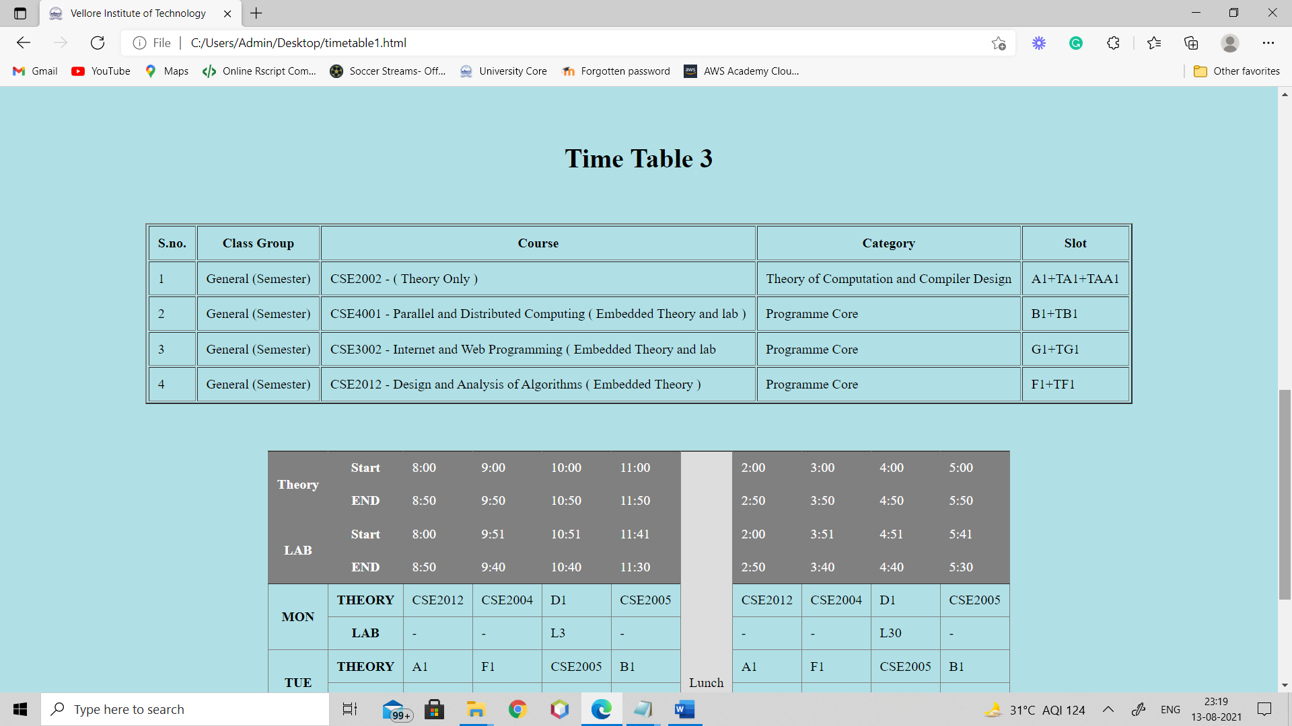

**Final Time table**

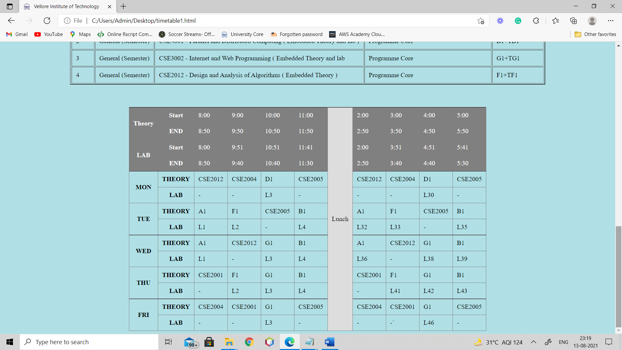

**Student life page:**

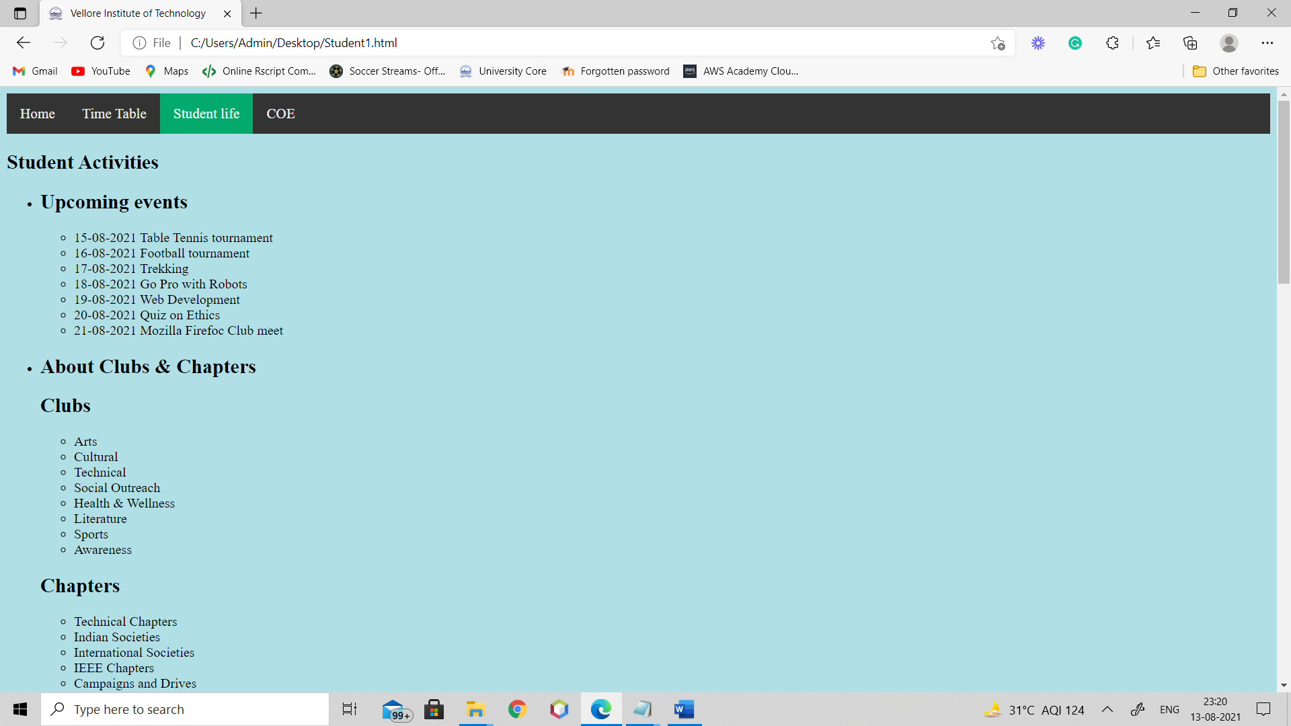

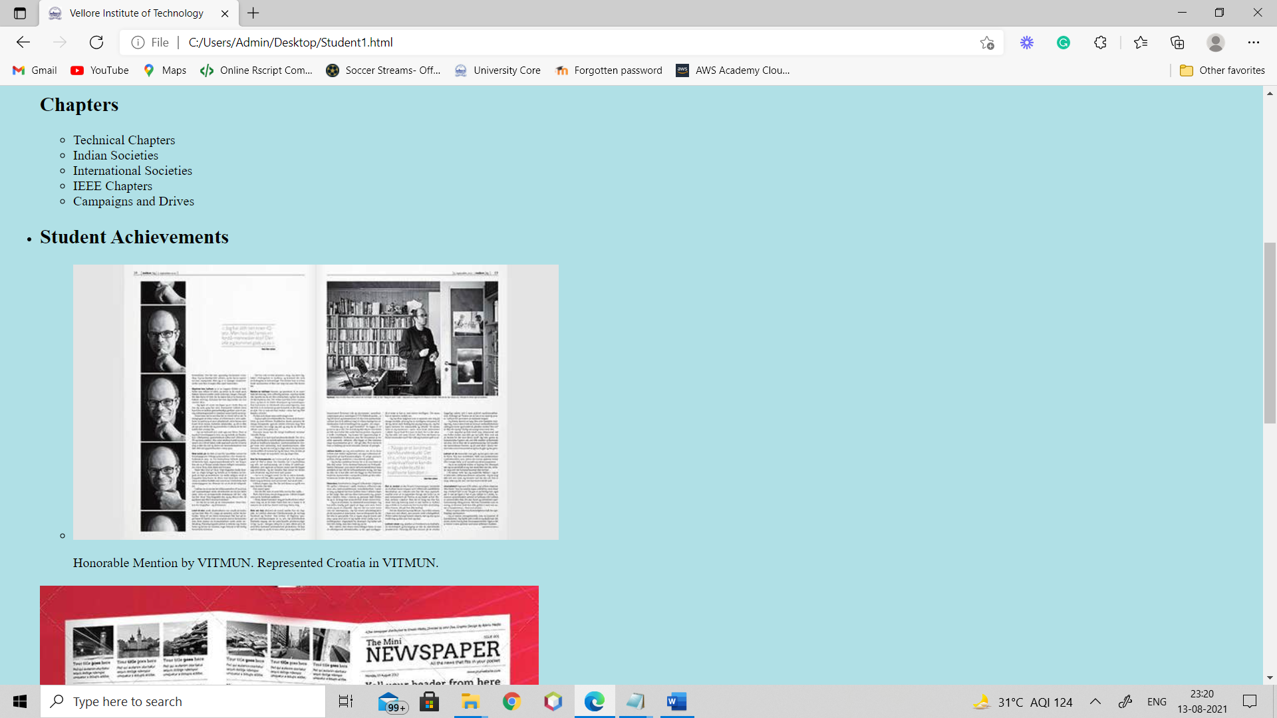

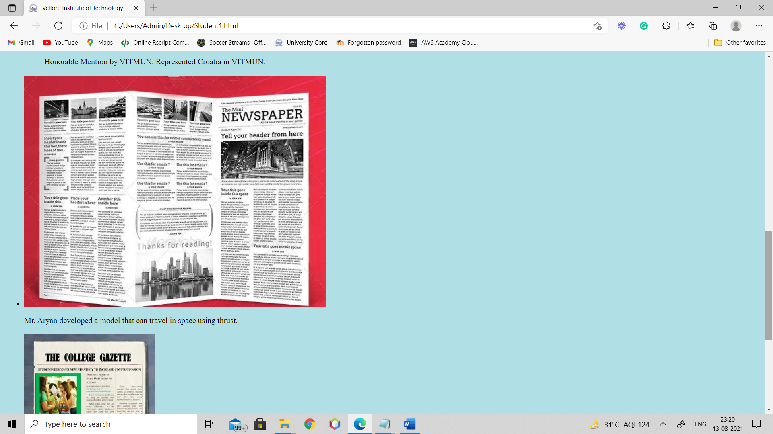

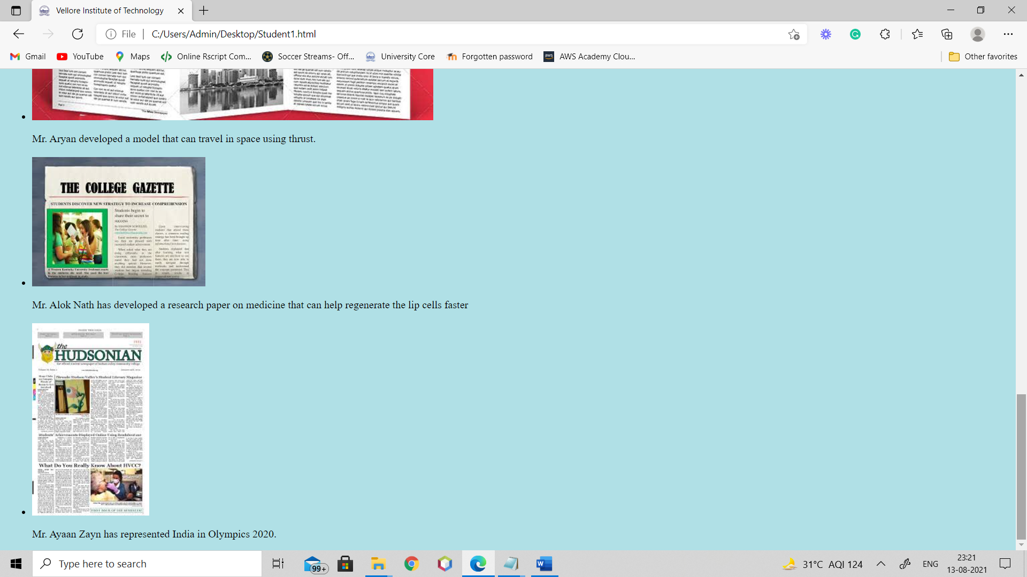

**COE page:**

**Time table**

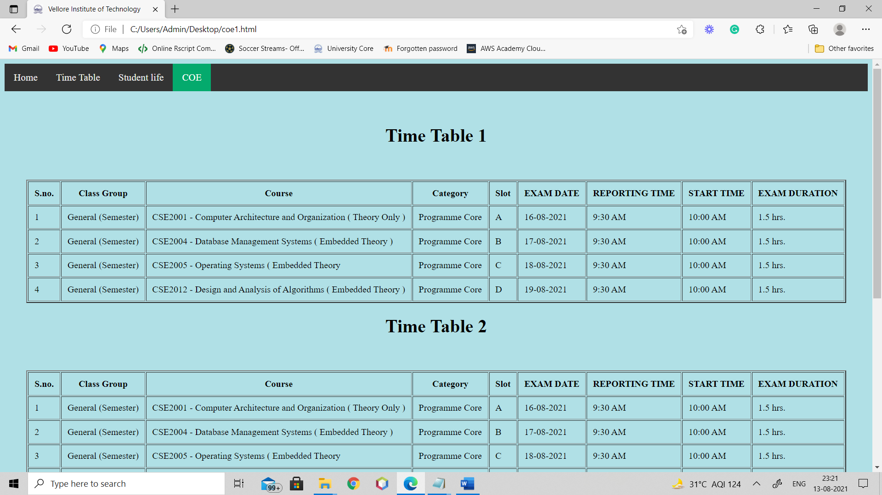

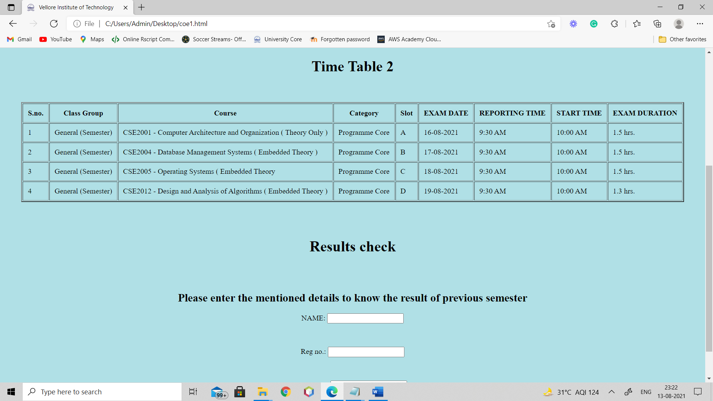

**Result Check**

